Chapter 5, Problem 15

- Determine the ratio v_{o}/i_{s} in the op amp circuit of Fig. 5.54.
- Evaluate the ratio for R₁ = 20 kΩ, R₂ = 25 kΩ, R₃ = 40 2kOmega$.

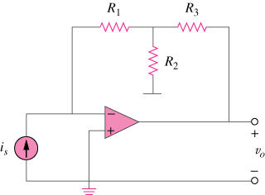

Figure 5.54
For Prob. 5.15.

